**ShopNest Key Business Analytics**

# Top Categories by Total Price

## Identify and visually represent the top 10 product categories by total sales.

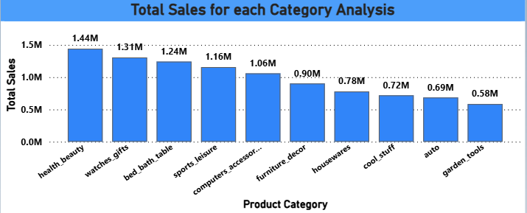

The chart clearly shows which product categories generate the highest sales.

categories such as Health Beauty, Watches Gifts and Bed bath table may appear as top contributors indicating strong market demand in these segments.

The dominance of certain categories in total sales suggests focused customer interest and purchasing behavior. Businesses can leverage this data to optimize product offerings and improve profitability by reinforcing the strengths in these high-performing categories. Conversely categories outside the top 10 may require review for potential growth.

# Delayed Order Analysis

## Determine the number of delayed orders in each category.

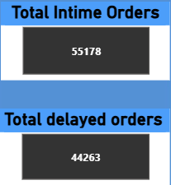

The analysis of order delivery timeliness reveals that out of a total of 99,441 orders approximately 55.47% were delivered on time while 44.53% experienced delays.

This indicates that just over half of the orders met the expected delivery schedules, highlighting significant room for improvement in the supply chain and logistics processes.

The relatively high percentage of delayed orders may impact customer satisfaction and loyalty emphasizing the need for targeted strategies to streamline order fulfillment. Possible actions include enhancing supplier coordination, improving inventory management and optimizing delivery routes to reduce delays. Focusing on these areas can help increase the proportion of on-time deliveries, thereby boosting operational efficiency and customer trust.

# Monthly Comparison of Delayed and On-Time Orders

## Create a dynamic visual that compares the number of delayed orders to the number of orders received earlier for each month.

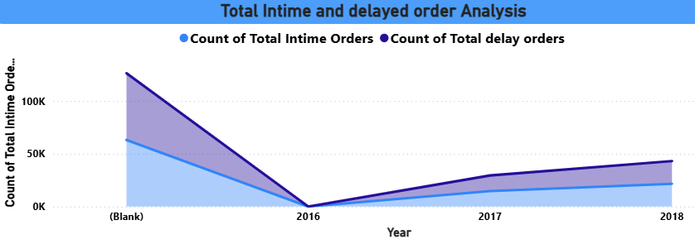

This dynamic visual compares the number of delayed orders against on-time orders for each month providing a clear timeline view of delivery performance. The inclusion of slicers for month and product category helps to view each month and category information.

The chart reveals fluctuations in order delivery performance over time helping identify months with higher delay rates.

This month-wise comparison helps in diagnosing the temporal patterns of order delays making it easier for management to allocate resources efficiently and plan corrective actions in advance.

# Payment Method Analysis

## Analyze the most frequently used payment methods by customers using a visually appealing representation.

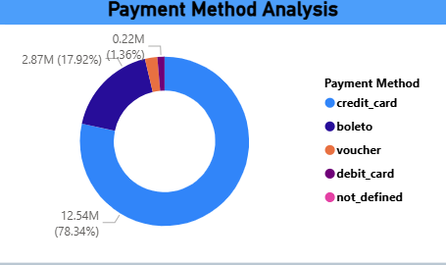

This visual aims to identify the payment methods most commonly used by customers providing insights into customer preferences and transaction behavior.

The chart highlights the distribution of payment methods such as Credit cards, Boleto, Voucher and Debit card.

By focusing on the most popular payment methods the company can streamline payment processing, reduce transaction failures and improve customer satisfaction. Additionally, targeted marketing campaigns or discounts can be designed around preferred payment channels to boost sales and loyalty.

# Product Rating Analysis

## Determine the top 10 highest-rated products and the bottom 10 lowest-rated products.

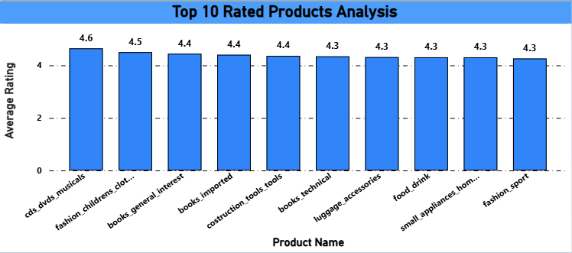

This visual identifies the products that received the highest and lowest customer ratings offering a clear view of product performance and customer satisfaction.

The top 10 highest-rated products represent items that consistently meet or exceed customer expectations, often correlating with quality, reliability or value.

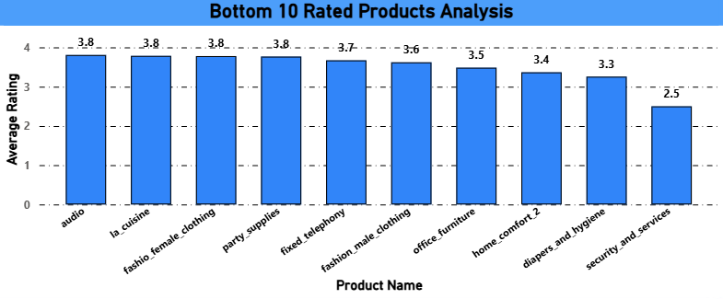

The bottom 10 lowest-rated products indicate potential issues such as quality concerns unmet customer needs or product defects.

Focusing on the highest-rated products can guide marketing and inventory decisions to capitalize on customer preferences. Conversely, analyzing the lowest-rated products provides valuable feedback for product development teams to improve offerings, reduce returns and enhance overall brand reputation.

# State-wise Sales Analysis

## Identify and visually represent states with high and low sales.

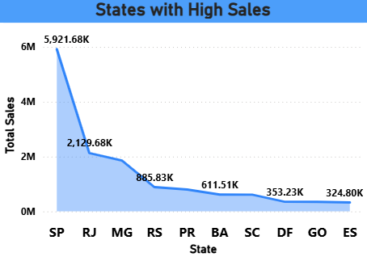

This visual represents the geographical distribution of sales across different states highlighting regions with high and low sales volumes.

This chart clearly identifies states with the highest sales which may correlate with population density, economic activity or market penetration.

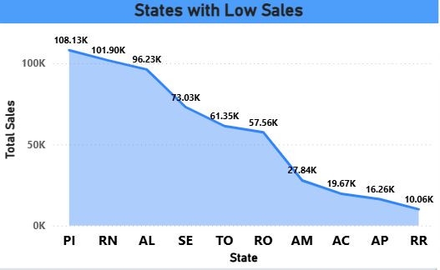

This chart identifies states with the lowest sales figures, which could be due to factors such as limited market presence, lower population density or ineffective marketing strategies.

These areas represent opportunities for growth through targeted campaigns, improved distribution channels or localized promotions.

By focusing on states with low sales, the business can develop focused initiatives to increase brand awareness and customer engagement in under performing markets. This targeted approach can ultimately enhance overall sales performance and market penetration.

# Seasonal Sales Patterns

## Investigate and visualize any seasonal patterns or trends in sales data over the course of the year.

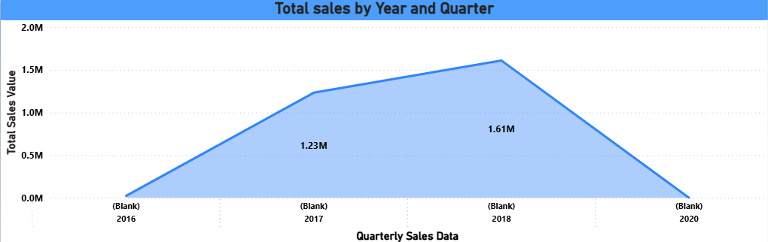

This dynamic visual explores seasonal patterns and trends in sales data across the year enhanced with slicers for both month and quarter.

For instance, certain quarters or months may consistently show sales spikes likely linked to holidays, festivals, or promotional campaigns.

The ability to filter by month or quarter allows a detailed examination of specific time frames and their impact on sales.

Understanding these seasonal trends helps the business forecast demand more accurately and align marketing, inventory and staffing strategies accordingly.

# Revenue Analysis

## Determine the total revenue generated by ShopNest Store and analyze how it changes over time.

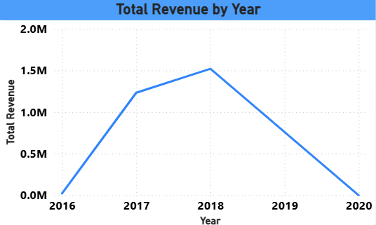

This visual tracks the total revenue generated by ShopNest Store over a defined time period providing insights into the store’s financial performance and growth trends.

Peaks in revenue may correspond with successful promotions, new product launches or seasonal demand increases.

Analyzing revenue trends over time allows the business to evaluate the effectiveness of sales strategies and market conditions impacting performance.